
Guidance on what constitutes a remittance network provider (RNP)
Guidance note 12/03
Anti-Money Laundering and Counter-Terrorism Financing Act 2006 (AML/CTF Act)

Introduction
  - The purpose of this guidance note is to provide assistance to remittance service providers in determining whether they are required to register as a remittance network provider.
  - All remitters are required to be registered with AUSTRAC before they provide remittance services. The remittance network provider is also responsible, among other things, for registering its remittance affiliates with AUSTRAC.
  - Remitters are required to apply for registration as an independent remittance dealer, a remittance network provider or an affiliate of a remittance network provider. It is possible for a remitter to fall within more than one registration category. For example, depending on how it conducts its remittance activities, a remitter may be both an independent remittance dealer and an affiliate of a remittance network provider.
  - Refer to AUSTRAC Guidance Note 12/01 – Registration obligations for remittance service providers from 1 November 2011 or the AUSTRAC website for more information about the registration process.

Defining a remittance network provider
  - A remittance network provider is a non-financier who operates a network of persons by providing a platform or operating system where the persons in the network are also non-financiers and provide a designated remittance service by:
  - accepting an instruction from a transferor entity for the transfer of money or property under a designated remittance arrangement (item 31); and/or
  - making money or property available, or arranging for it to be made available, to an ultimate transferee entity as a result of a transfer under a designated remittance arrangement (item 32).
  - In simple terms, remittance network providers:
- operate a network of persons, called ‘affiliates’, who provide remittance services to customers of the network; and
- provide a shared or common platform or operating system used by their affiliates within the network to provide remittance services.

‘Operating’ a network of persons or affiliates
  - The word ‘operating’ is not defined in the AML/CTF Act. It is AUSTRAC’s view that ’operating’ suggests the exertion of some form of influence or control over the operation of the remittance service. Further, AUSTRAC considers that the term ‘operate’ also implies a management role.
  - On this basis, AUSTRAC considers that a remittance network provider must be able to exert some form of influence over the operation of its network of affiliates in providing remittance services. These arrangements may be outlined in the form of a contract or commercial agreement negotiated between the remittance network provider and each affiliate.

Providing a platform or operating system
  - The provision of a platform or operating system encompasses the systems and arrangements used by remittance affiliates to provide remittance services to their customers.
  - AUSTRAC considers that the platforms and operating systems used by remittance network providers vary considerably and include technology-based systems such as computer programs or software, internet, intranet, e-mail services and other forms of communication, including facsimile machines, telephone or SMS. Remittance network providers may also employ manual communication operating systems; for example, paper-based systems.

Other features of a remittance network provider
  - A remittance network provider will generally exhibit the following features:
- a contract (or agreement) with each affiliate within its network which sets out the terms and conditions of the arrangement by which the affiliate will provide remittance services to its customers
- a schedule of commissions and/or service fees payable to the affiliate for each remittance transaction completed by customers
- the provision of branding and/or signage for the remittance services offered.

Geographical link
  - Subsection 6(6) of the AML/CTF Act excludes remittance network providers from the ‘geographical link’ requirements which apply to other reporting entities.
  - This means that a remittance network provider is subject to the AML/CTF regulatory framework if it provides services to affiliates that are located in Australia regardless of whether the remittance network provider itself is located in Australia.
  - Accordingly, a remittance network provider does not need to have a permanent establishment in Australia in order to be bound by the requirements of the AML/CTF Act. It may be a resident of Australia, a subsidiary of a company that is a resident of Australia or resident in a foreign country (see examples C and D below).

The difference between a network of affiliates and a network of branches
  - Affiliates of remittance network providers are independent businesses in their own right which are not owned by the remittance network provider. The remittance network provider enters into a contract or agreement with each of its affiliates for the provision of remittance services but does not exercise control over other business activities undertaken by those affiliates.
  - By contrast, a remitter may offer its services through a network of branches which it owns and controls. The remitter employs the branch network staff and is responsible for the operating costs of the branches such as rent on offices and payment for utilities. In this situation, the remitter (together with its branch network) are treated as a single entity and would be characterised, for registration purposes under the AML/CTF Act, as being an independent remittance dealer (see example B below).

The status of a ‘super-agent’ or intermediary
  - Some remittance network providers use intermediaries, often referred to as ‘super-agents’. The super-agent is typically an entity which operates as an intermediary, between the remittance network provider and a group of its affiliates, and represents the interests of those affiliates within the broader remittance network in all primary communications, contractual arrangements and dealings with the remittance network provider. The super-agent operates as a second tier of control and management within the network, often providing administrative support services to the network providers. These super-agents do not provide the platform used by the network for providing remittance services. The platform or operating system is made available to remittance affiliates by the remittance network provider.
  - A super-agent or intermediary is not subject to the AML/CTF regulatory framework if it only provides ancillary administrative support services to the remittance network provider. For example, this would include recruitment and ‘on-boarding’ of affiliates, providing AML/CTF programs adopted or approved by the remittance network provider, training and compliance templates and tools, and undertaking coordination functions across affiliates. In this capacity the relationship with the remittance network provider is a commercial arrangement (see examples C & D below).
  - However, if a super-agent is also engaged by the remittance network provider to provide remittance services directly to customers, the super-agent may be an affiliate of the remittance network provider.

Examples
  - Below are four examples of the types of business structures which may be operating within the remittance network sector. These examples do not cover all circumstances and AUSTRAC encourages any entity which is unsure whether it is operating a remittance network to contact the AUSTRAC Help Desk on 1300 021 037 for further assistance.

Example A: A remittance network provider may also be an affiliate of another remittance network provider
- ABC Pty Ltd provides a remittance service directly to customers in 50 countries.
- ABC Pty Ltd also operates a network of affiliates under a service agreement with each affiliate.
- ABC Pty Ltd provides the affiliates with an operating platform, branding, a remittance fee and commission structure, ongoing training of staff, a customer service help line, promotional advertising and also submits reports to AUSTRAC as required under the AML/CTF Act. ABC Pty Ltd must register as a remittance network provider.
- ABC Pty Ltd also has a contractual arrangement to operate as an affiliate of Acme Remittance Limited (Acme Remittance), an international corporation which provides remittance to countries in Asia and the Pacific for corporate clients. Acme Remittance is responsible for registering ABC Pty Ltd as a remittance affiliate. ABC Pty Ltd can, however, with the consent of Acme Remittance, register as an affiliate on its own behalf.
- ABC Pty Ltd utilises an online portal provided by Acme, in conjunction with its own portal to undertake international fund transfers. ABC Pty Ltd must also register with AUSTRAC as an independent remittance dealer.

Example A
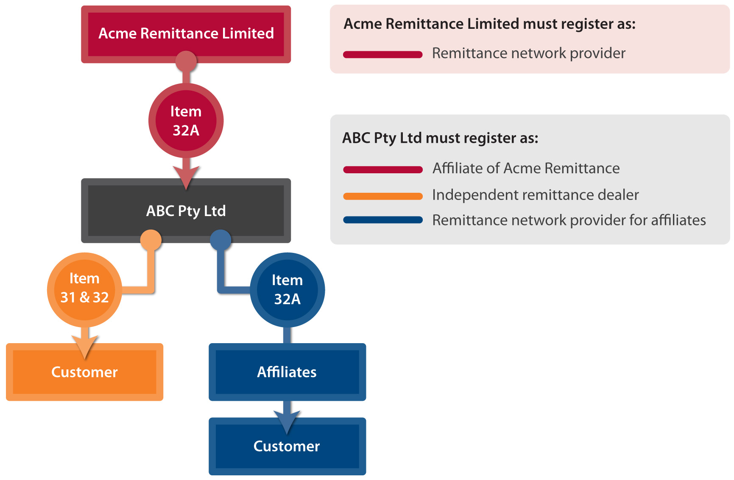

Summary of registration obligations

Acme Remittance Limited must register as:
- a remittance network provider because it operates an affiliate in Australia (that is, ABC Pty Ltd).

ABC Pty Ltd must register as:
- a remittance network provider, because it operates a network of affiliates in Australia
- an independent remittance dealer, because it offers its remittance services directly to its customers
- an affiliate of Acme Remittance.

Example B: For registration purposes an entity with a network of branches is considered an independent remittance dealer
- ABC PLC is a UK registered public and listed corporation which provides a range of financial services to customers within Australia, including remittance services through a branch network using its own global proprietary platform.
- ABC PLC has established an Australian subsidiary, ABC (Australia) Pty Ltd, to manage its business operations and branch network in Australia.
- ABC (Australia) Pty Ltd has branches located in each of the major capital cities in Australia, as well as all the large regional centres and major airports.
- A customer can conduct an international funds transfer from an ABC (Australia) Pty Ltd branch in Australia to another ABC PLC branch in a foreign country.
- ABC (Australia) Pty Ltd has no other affiliations or arrangements with any other financial service provider in Australia.
- ABC (Australia) Pty Ltd is required to register with AUSTRAC as an independent remittance dealer.

Example B
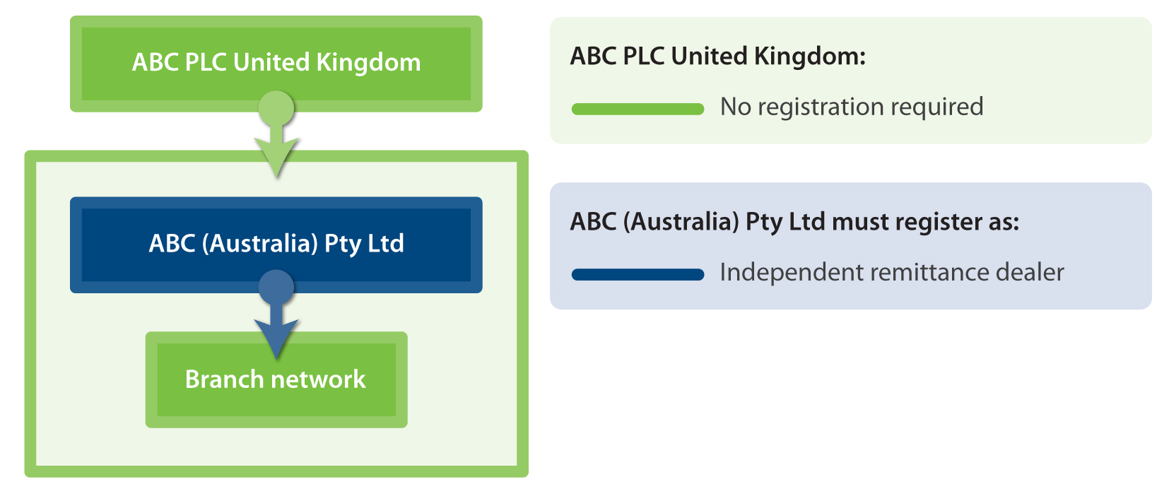

Summary of registration obligations

ABC (Australia) Pty Ltd must register as:
- an independent remittance dealer because it offers remittance services directly to its customers.
ABC (Australia) Pty Limited is required to register because it is operating as an independent remittance dealer in Australia. ABC (Australia) Pty Limited is a subsidiary of ABC PLC United Kingdom and is registered in and a resident of Australia.

Example C: Super-agents: Only parties who are involved in the remittance transaction are required to register with AUSTRAC
- Super Management Pty Ltd, an Australian registered company, has been engaged by Acme Remittance of India, a remittance network provider established in India, to provide certain administrative support services on its behalf to 150 Acme Remittance affiliates operating in New South Wales. Acme Remittance of India must register as a remittance network provider.
- The services provided to the 150 affiliates by Super Management Pty Ltd on behalf of Acme Remittance of India are specified in a contract and include supervisory oversight, training, education, operating a help line and conducting audit reviews from time-to-time.
- Super Management Pty Ltd has not been engaged to provide remittance services as described at items 31 and 32 of the AML/CTF Act.
- Super Management Pty Ltd does not conduct or accept remittance transactions or hold monies relating to transactions or have any face-to-face interaction with the customers. All remittance transactions are provided by the registered affiliates of Acme Remittance of India. Super Management Pty Ltd is not required to register in any capacity. Acme Remittance of India is responsible for registering its 150 affiliates as remittance affiliate. Any affiliates that also provide independent remittance services may however, with the consent of Acme Remittance of India, register as an affiliate on its own behalf.

Example C
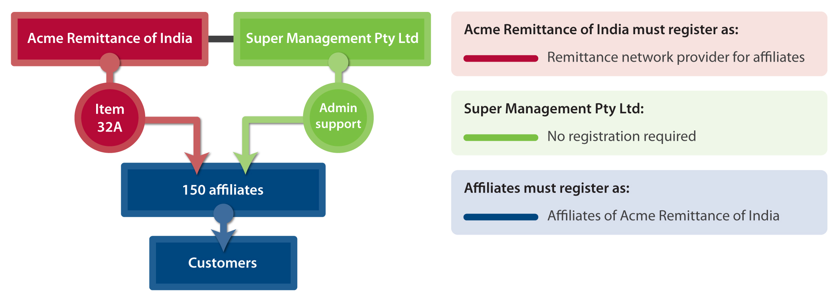

Summary of registration obligations

Acme Remittance of India must register as:
- a remittance network provider because it operates a network of affiliates in Australia.

Super Management Pty Ltd does not have to register with AUSTRAC in any capacity:
- as it does not provide a designated service at items 31 or 32 and is not operating a network of remittance affiliates in Australia in accordance with item 32A.

The 150 affiliates must register as:
- affiliates of Acme Remittance of India.

Example D: Providers of ancillary administrative support services are not subject to the regulatory arrangements
- EndGame PLC is a public and listed UK company which offers a range of services to global clients including remittance, technological and accounting solutions.
- EndGame PLC has a contractual arrangement to provide technology services to a number of registered independent remittance dealers in Australia, enabling these entities through their banks to transfer monies from their Australian bank accounts to the bank accounts of their overseas counterparts.
- EndGame PLC is not operating a network of affiliates and the remittance service providers are all independent of each other.
- Simply providing a platform or operating system does not constitute operating a network of persons or affiliates. The owner of the platform or operating system must be able to exert some form of control or influence, or manage the persons in the network, in order to be considered to be providing the item 32A designated service under the AML/CTF Act.
- In this example, EndGame PLC is only the technology service provider. It merely provides the platform or operating system to the remittance dealers and does not exert control or influence or manage any remittance dealers.

Example D
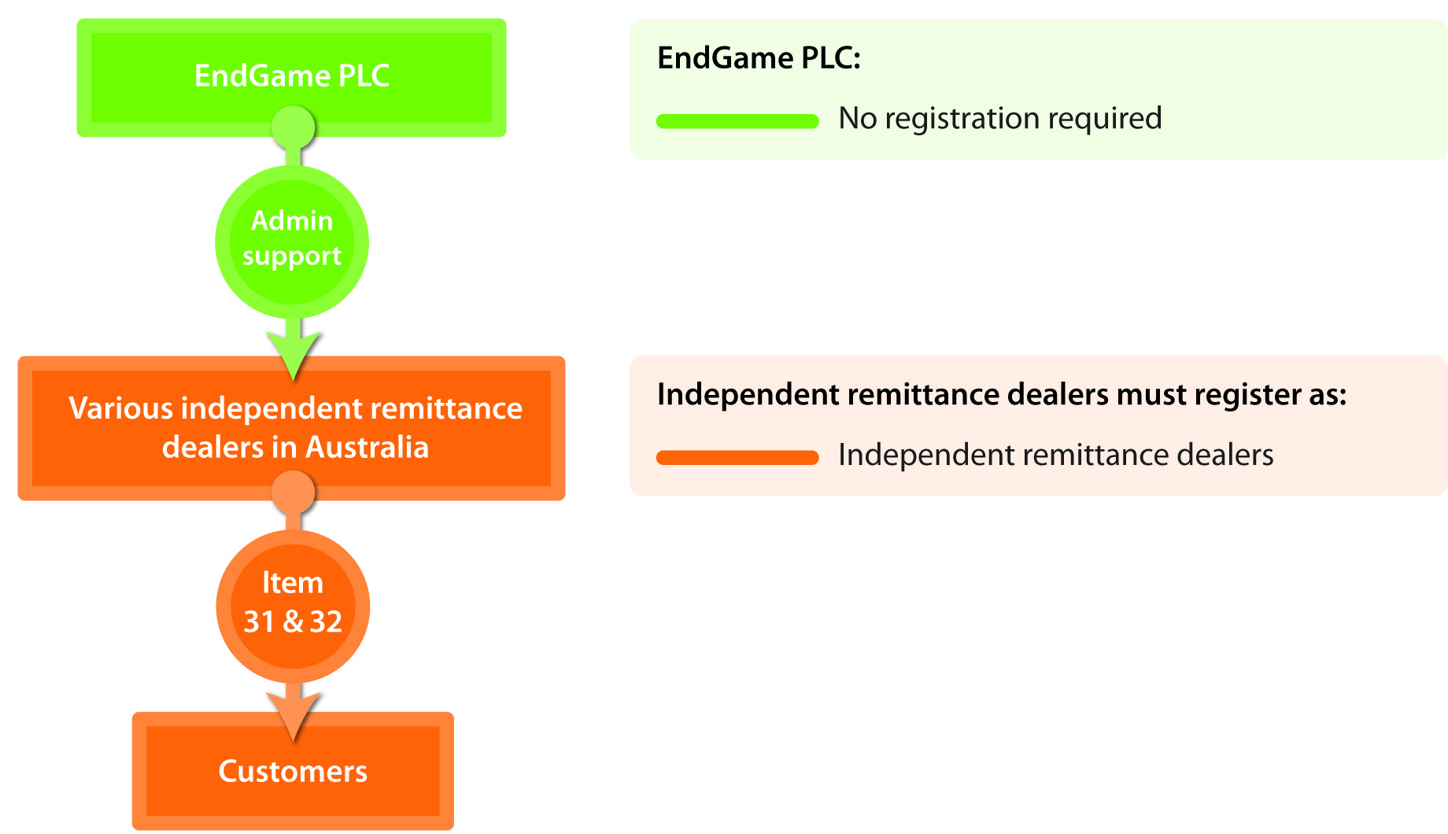

Summary of registration obligations

EndGame PLC does not have to register with AUSTRAC in any capacity:
- as it does not provide a designated service at items 31, 32 and is not operating a network of remittance affiliates in Australia in accordance with item 32A.

The remittance dealers using the EndGame PLC platform must register as:
- independent remittance dealers because they provide remittance services to their customers.

Further information
  - AUSTRAC officers are able to assist reporting entities, their staff and the public in providing general information relating to the AML/CTF Act. Enquiries can be directed to the AUSTRAC Help Desk via:
- email to help_desk@austrac.gov.au
- telephone 1300 021 037 (a local call within Australia).
  - The information contained in this document is intended only to provide a summary and general overview on these matters. It is not intended to be comprehensive. It does not constitute, nor should it be treated as, legal advice or opinions. This document may contain statements of policy which reflect AUSTRAC’s administration of the legislation in carrying out its statutory functions. The Commonwealth accepts no liability for any loss suffered as a result of reliance on this publication. AUSTRAC recommends that independent professional advice be sought.
  - The information contained herein is current as at the date of this document.
Reporting entities should note that in relation to activities they undertake to comply with the AML/CTF Act, they will have obligations under the Privacy Act 1988, including the requirement to comply with the National Privacy Principles, even if they would otherwise be exempt from the Privacy Act. For further information about these obligations, please go to http://www.oaic.gov.au or call 1300 363 992.

12/2012
© Commonwealth of Australia
Australian Transaction Reports and Analysis Centre (AUSTRAC)
PO Box 5516
West Chatswood NSW 1515
Telephone: 1300 021 037
Facsimile: 02 9950 0071
Website: www.austrac.gov.au
Email: help_desk@austrac.gov.au

Where an affiliate also provides independent remittance services, the affiliate itself may apply for registration as an affiliate, with the written consent of the relevant network provider.
Non-financier means a person who is not: i) an authorised deposit-taking institution ii) a bank iii) a building society iv) a credit union v) a person specified in the AML/CTF Rules. The AML/CTF Rules, at Chapter 23 specify the following persons: • a person carrying on an accounting practice • a person carrying on a law practice
By ‘influence’, AUSTRAC means the ability to compel another to do something.
Refer to subsection 6(6) of the AML/CTF Act.

